Namibia

## Political Stability Estimate Data

The data set shows the political stability estimate of the country each year.

## # A tibble: 19 x 5  
## country iso3c date stability stabilityCategory4   
## <chr> <chr> <dbl> <dbl> <chr>   
## 1 Namibia NAM 1996 0.855 moderately stable   
## 2 Namibia NAM 1998 0.506 moderately stable   
## 3 Namibia NAM 2000 -0.254 moderately unstable  
## 4 Namibia NAM 2002 0.145 moderately stable   
## 5 Namibia NAM 2003 0.478 moderately stable   
## 6 Namibia NAM 2004 0.664 moderately stable   
## 7 Namibia NAM 2005 0.625 moderately stable   
## 8 Namibia NAM 2006 0.783 moderately stable   
## 9 Namibia NAM 2007 1.02 highly stable   
## 10 Namibia NAM 2008 1.20 highly stable   
## 11 Namibia NAM 2009 0.928 moderately stable   
## 12 Namibia NAM 2010 0.847 moderately stable   
## 13 Namibia NAM 2011 0.912 moderately stable   
## 14 Namibia NAM 2012 0.978 moderately stable   
## 15 Namibia NAM 2013 0.959 moderately stable   
## 16 Namibia NAM 2014 0.609 moderately stable   
## 17 Namibia NAM 2015 0.733 moderately stable   
## 18 Namibia NAM 2016 0.710 moderately stable   
## 19 Namibia NAM 2017 0.650 moderately stable

## Political Stability Estimate Plot

The plot shows the trends of stabilization and destabilization for the each country.

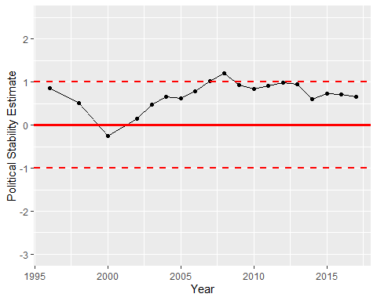

Political Stability Trend